**Experiment No. 2.1**

**Student Name:** Gaurav Kumar **UID:** 22MCC20177

**Branch:** MCA**–**CCD **Section/Group:** MCD-1/A

**Semester:** III **Date of Performance:** 15th Oct 23

**Subject Name:** CONTAINERIZATION **Subject Code:** 22CAH-742

WITH DOCKER

1. **Aim/Overview of the practical:**
   1. Understanding the Docker file for Customizing images.
2. **Code for practical: (a)**

**Creating a container through CLI**

1. First we have to create a folder using **mkdir** command.
2. Enter that folder using the command **cd**.

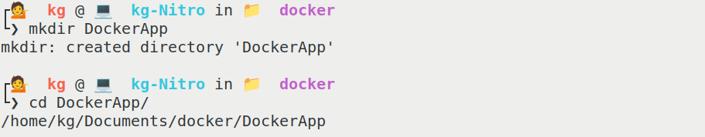

1. Create a File **helloworld.py** using command **echo.**

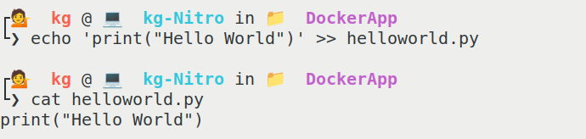

1. Create a Dockerfile using command **nano Dockerfile.**

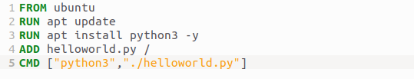

→ Use the **FROM** instruction to specify the base image for your container.

**→ COPY: Copy** files and directories from the host system into the container image.

→ **ADD:** Similar to **COPY**, but more versatile. It can download files from URLs and extract compressed archives.

→ **WORKDIR:** Set the working directory for subsequent instructions. Any relative paths specified will be relative to this directory.

→ **EXPOSE: Expose** the ports on which the container listens for incoming connections (for documentation purposes):

→ **CMD:** is use to run the commands in container.

1. **Build the image using command “docker build -t DockerApp”.**

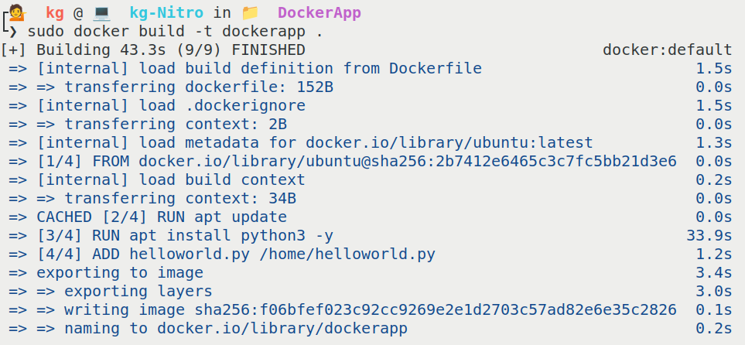

1. Run the image using command **docker run DockerApp**.

